# What is dirty data?

Earlier, we discussed that dirty data is data that is incomplete, incorrect, or irrelevant to the problem you are trying to solve. This reading summarizes:

* Types of dirty data you may encounter
* What may have caused the data to become dirty
* How dirty data is harmful to businesses

## **Types of dirty data**

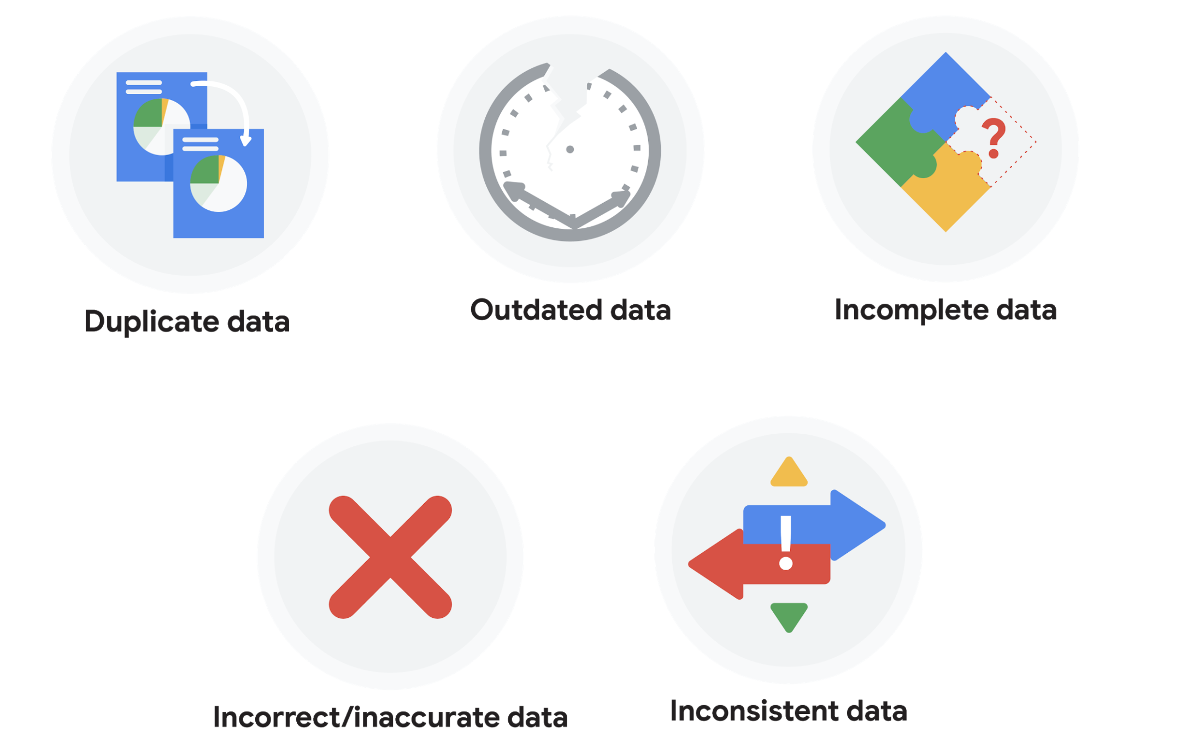

### **Duplicate data**

| **Description** | **Possible causes** | **Potential harm to businesses** |
| --- | --- | --- |
| Any data record that shows up more than once | Manual data entry, batch data imports, or data migration | Skewed metrics or analyses, inflated or inaccurate counts or predictions, or confusion during data retrieval |

### **Outdated data**

| **Description** | **Possible causes** | **Potential harm to businesses** |
| --- | --- | --- |
| Any data that is old which should be replaced with newer and more accurate information | People changing roles or companies, or software and systems becoming obsolete | Inaccurate insights, decision-making, and analytics |

### **Incomplete data**

| **Description** | **Possible causes** | **Potential harm to businesses** |
| --- | --- | --- |
| Any data that is missing important fields | Improper data collection or incorrect data entry | Decreased productivity, inaccurate insights, or inability to complete essential services |

### **Incorrect/inaccurate data**

| **Description** | **Possible causes** | **Potential harm to businesses** |
| --- | --- | --- |
| Any data that is complete but inaccurate | Human error inserted during data input, fake information, or mock data | Inaccurate insights or decision-making based on bad information resulting in revenue loss |

### **Inconsistent data**

| **Description** | **Possible causes** | **Potential harm to businesses** |
| --- | --- | --- |
| Any data that uses different formats to represent the same thing | Data stored incorrectly or errors inserted during data transfer | Contradictory data points leading to confusion or inability to classify or segment customers |

### **Business impact of dirty data**

For further reading on the business impact of dirty data, enter the term “dirty data” into your preferred browser’s search bar to bring up numerous articles on the topic. Here are a few impacts cited for certain industries from a previous search:

* Banking: Inaccuracies cost companies between 15% and 25% of revenue ([source](https://sloanreview.mit.edu/article/seizing-opportunity-in-data-quality/)).
* Digital commerce: Up to 25% of B2B database contacts contain inaccuracies ([source](https://www.demandgen.com/dirty-data-what-is-it-costing-you/)).
* Marketing and sales: 8 out of 10 companies have said that dirty data hinders sales campaigns ([source](https://www.dqglobal.com/2011/05/04/obsolete-or-dirty-data/)).
* Healthcare: Duplicate records can be 10% and even up to 20% of a hospital’s electronic health records ([source](https://searchhealthit.techtarget.com/feature/Hospitals-battle-duplicate-medical-records-with-technology)).